*Name: Karnam Nithin*

*Registration no: 21BAI1091*

* *CSE 2012- Design and Analysis of Algorithms In-lab*
* *Practice Sheet-1*

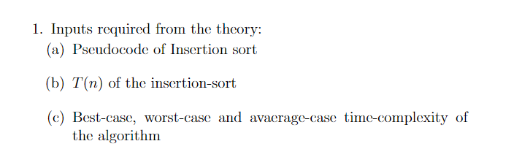

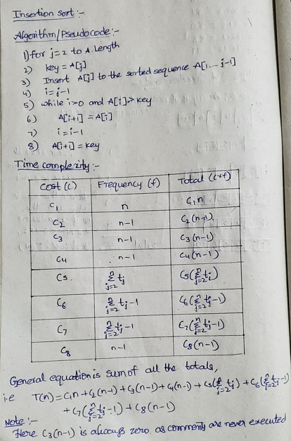

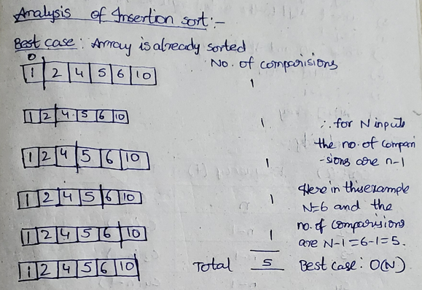

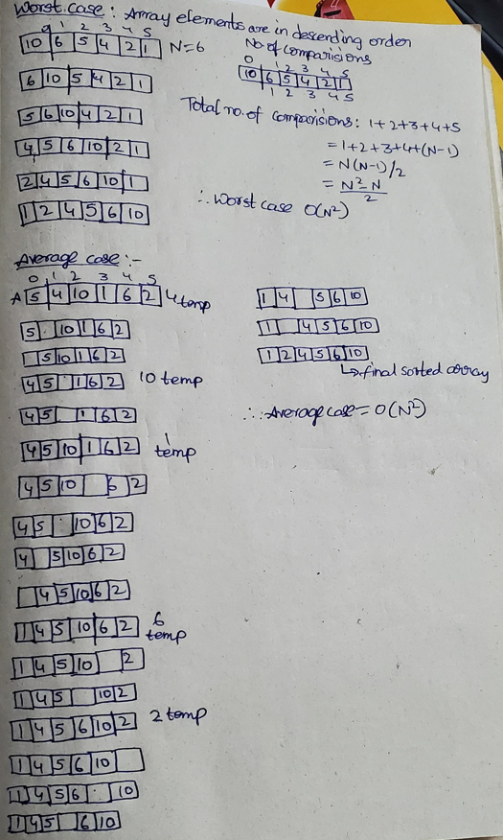

***Code Snippet for python inputs:***

***Random inputs:***

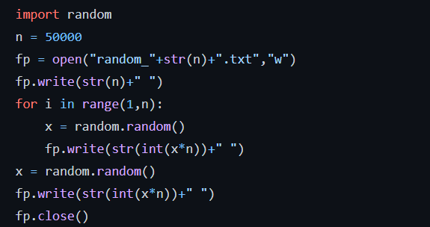

***Ascending inputs:***

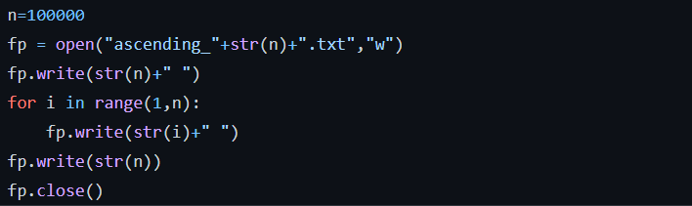

***Descending inputs:***

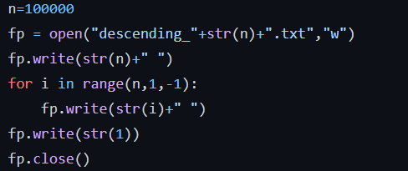

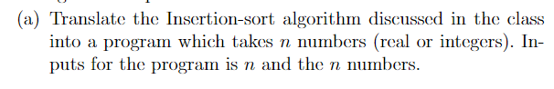

**Approach 1:(using vectors)**

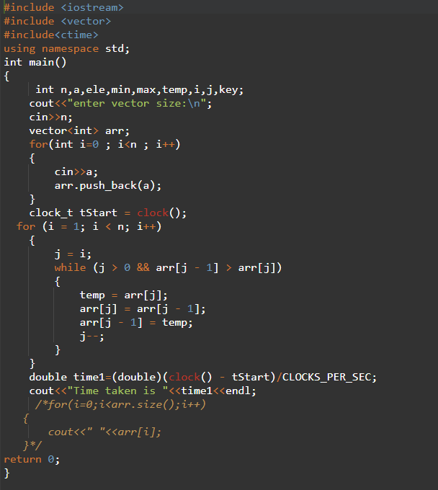

**Analysis:**

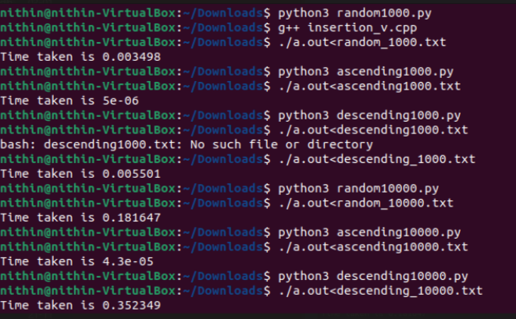

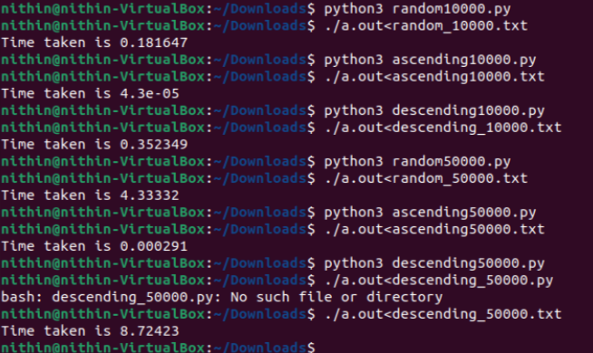

**Graph:**

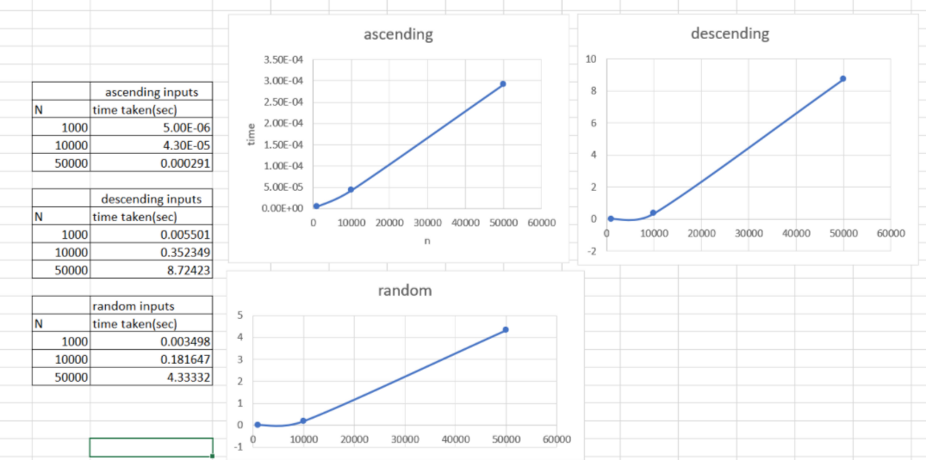

**Approach 2:(without vectors)**

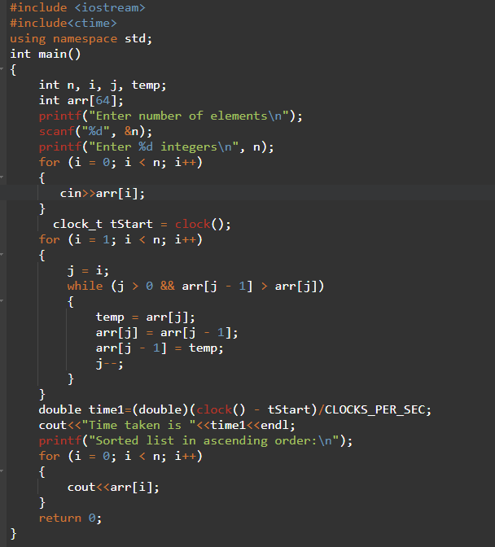

**Analysis:**

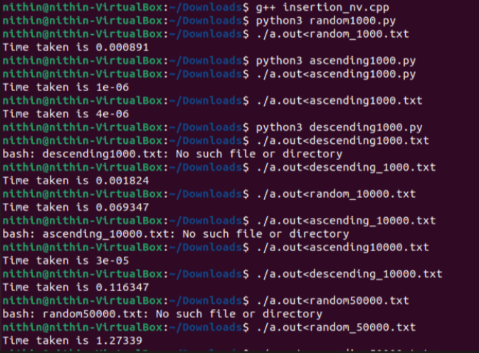

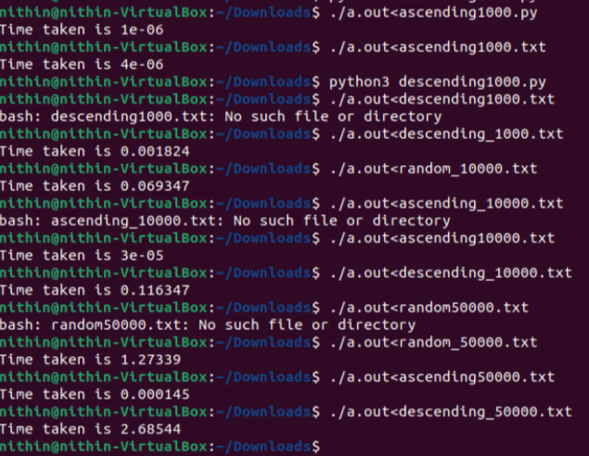

Graph:

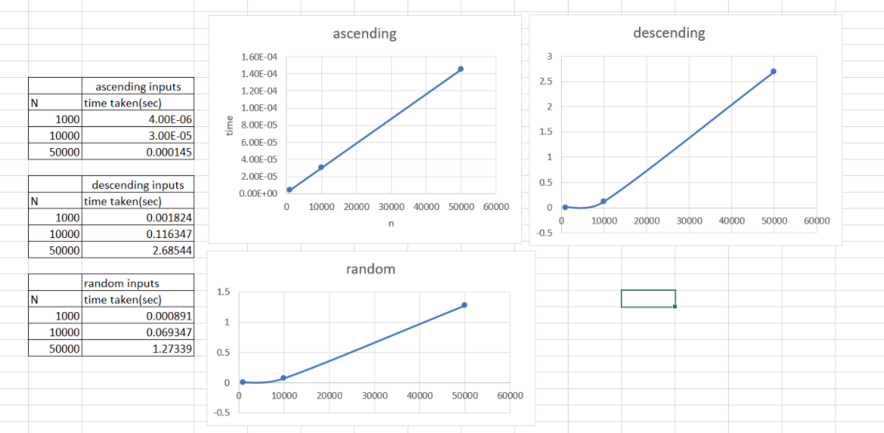

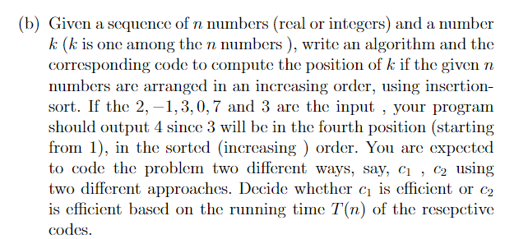

**Approach 1:(With vectors)**

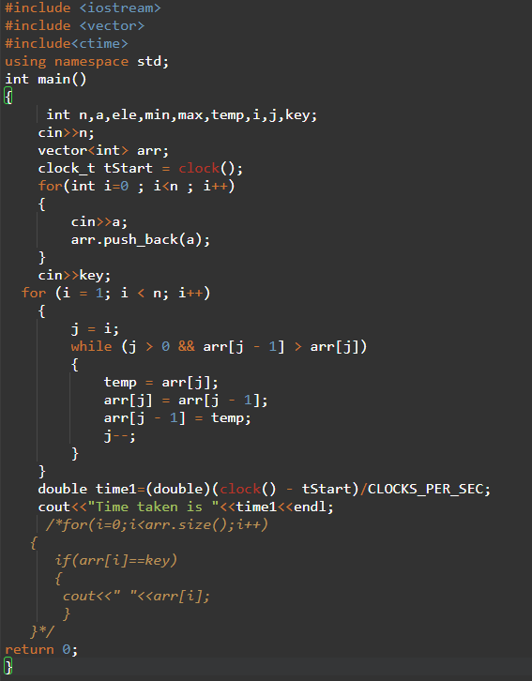

**Analysis:**

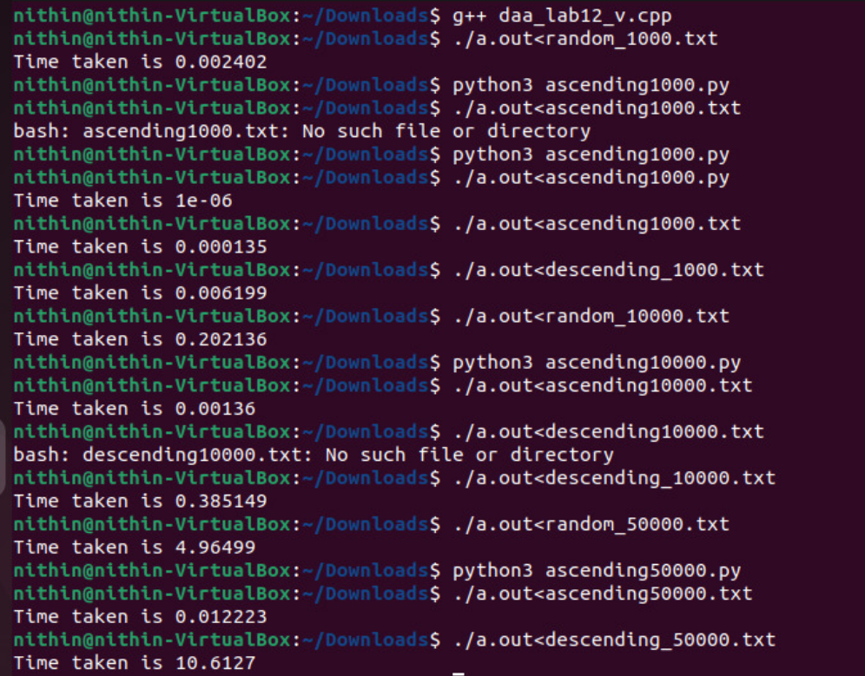

**Graph:**

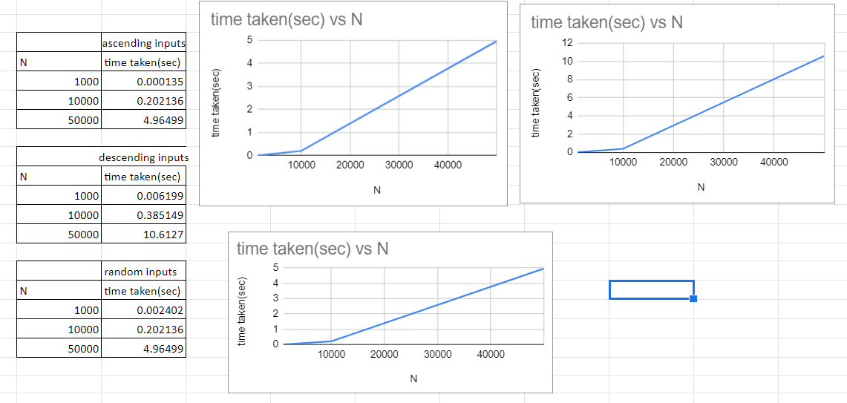

**Approach 2:(Without vectors)**

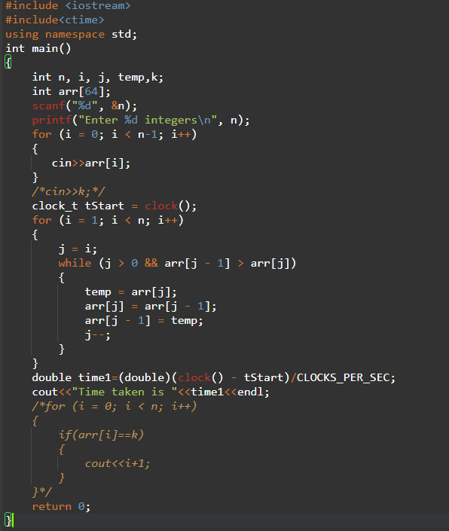

**Analysis:**

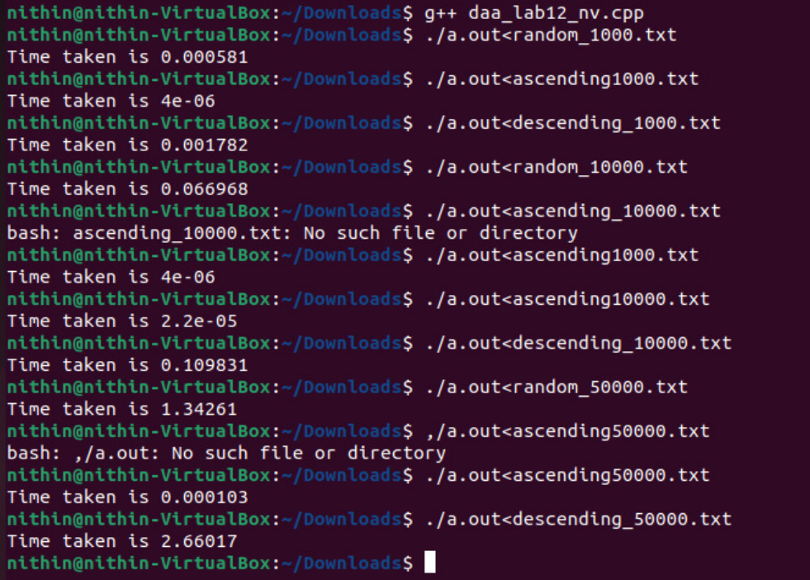

**Graph:**

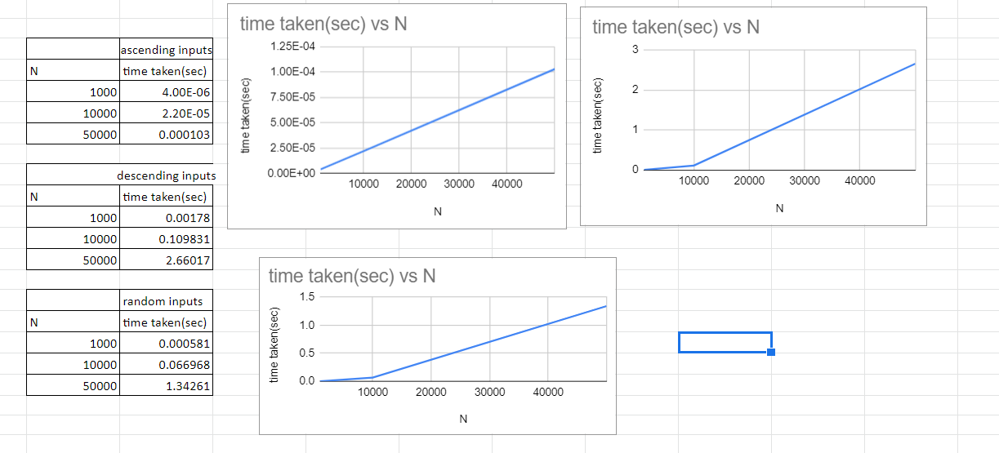

***Conclusion:***

Let cost c1 be for approach 1 and cost c2 be for approach2 from analysis and graphs we can observe that the worst case for approach 2 takes less time than approach 1 worst case, hence we can conclude that c2 is efficient

All the alphabets(lower case) of english languagea, b, c, ..., y, zare assigned values 1,2,3, ...,25,26. Given a sequence ofnsymbols from english alphabet (only lower case), write aninsertion-sort based algorithm to arrange the givennsym-bols, in an increasing order of their values. . You are expectedto code the problem two different ways, say,c1,c2using twodifferent approaches. Decide whether c1is efficient or c 2 is effi-cient based on the running timeT(n) of the resepctive codes

**Approach 1:(With vectors)**

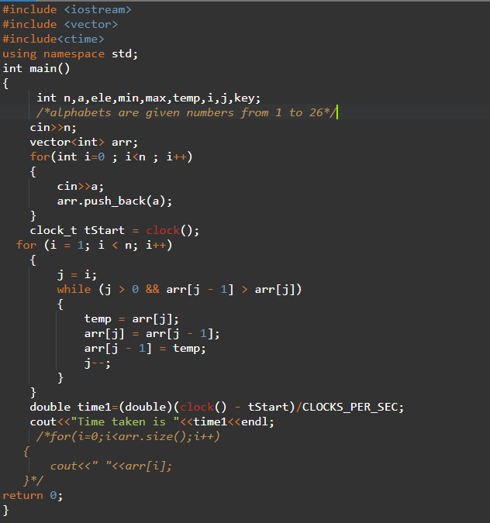

**Analysis:**

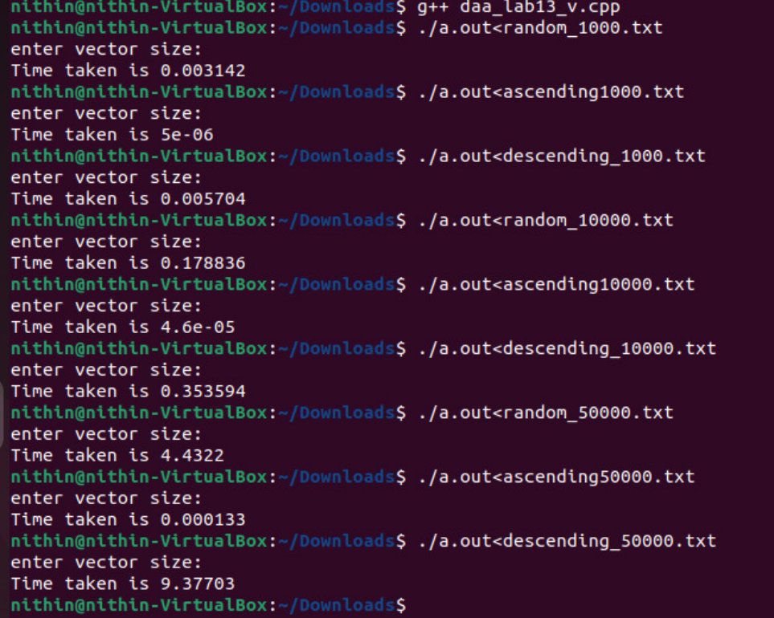

**Graph:**

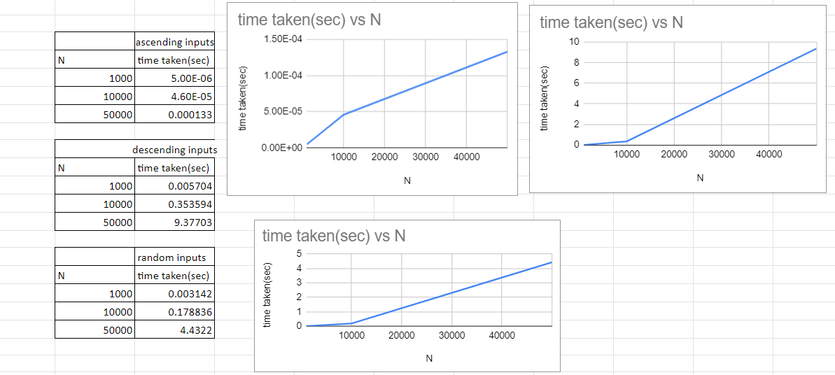

**Approach 2:(Without vectors)**

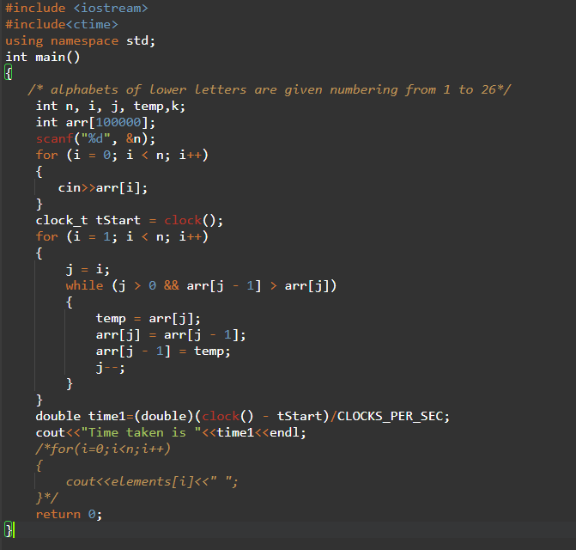

**Analysis:**

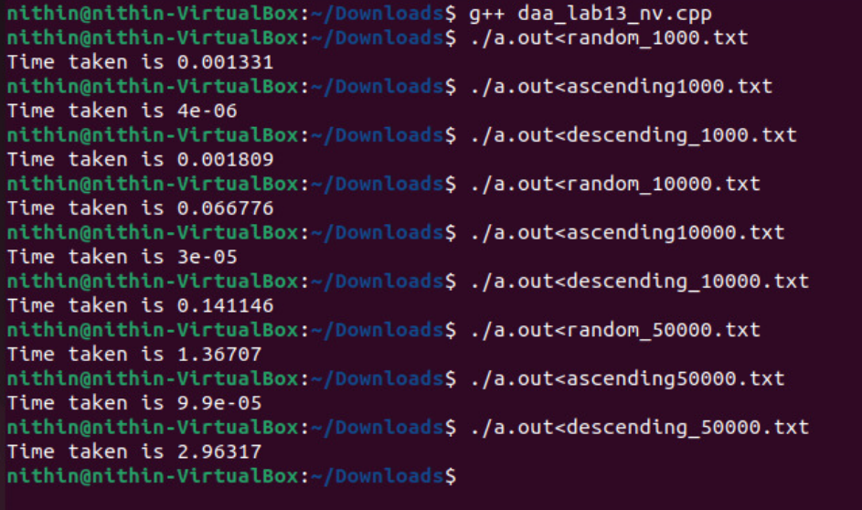

**Graph:**

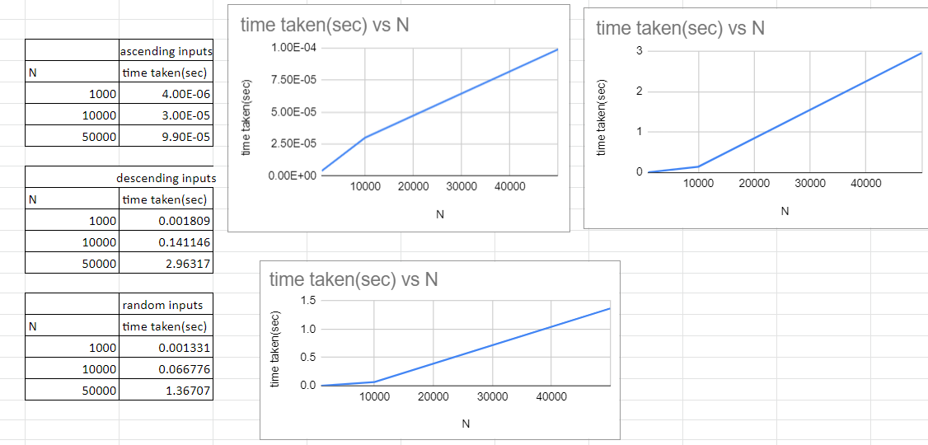

**Conclusion:**

Let cost c1 be for approach 1 and cost c2 be for approach2 from analysis and graphs we can observe that the worst case for approach 2 takes less time than approach 1 worst case, hence we can conclude that c2 is efficient

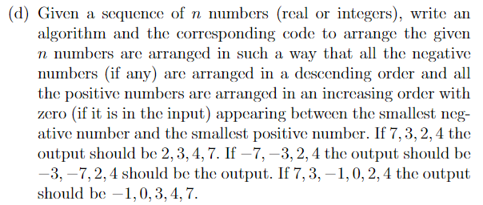

**Approach 1:(With vectors)**

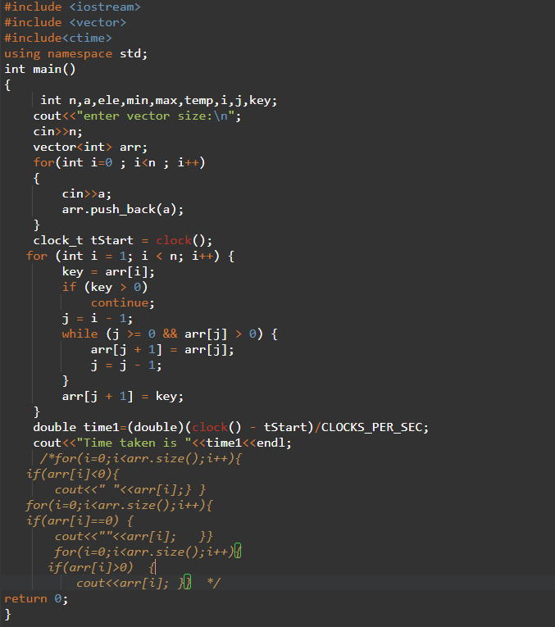

**Analysis:**

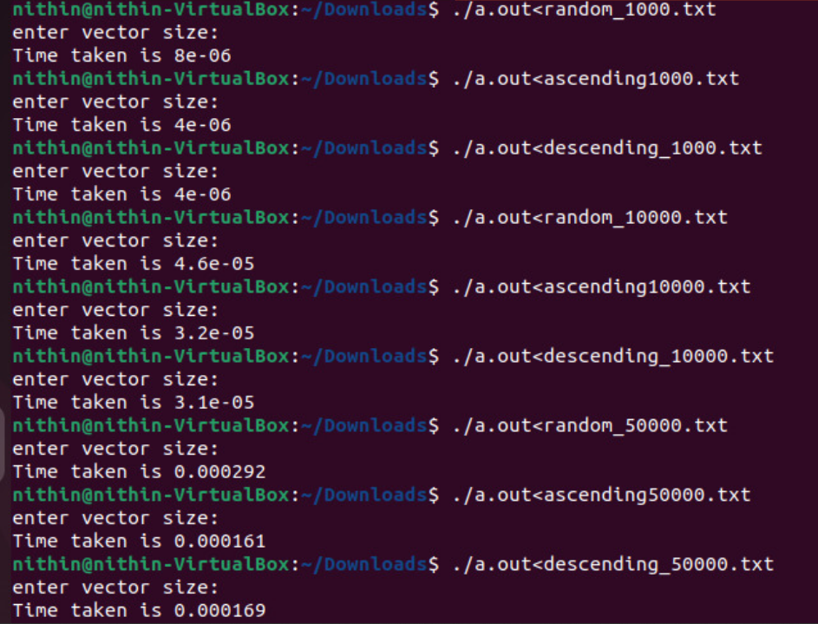

**Graph:**

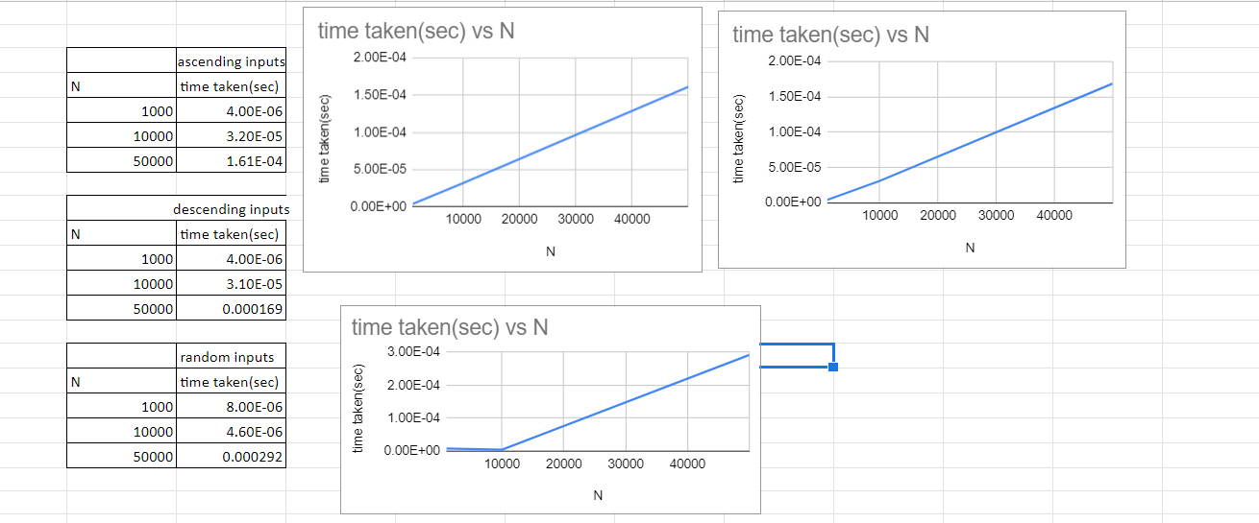

**Approach 2:**(Without vectors)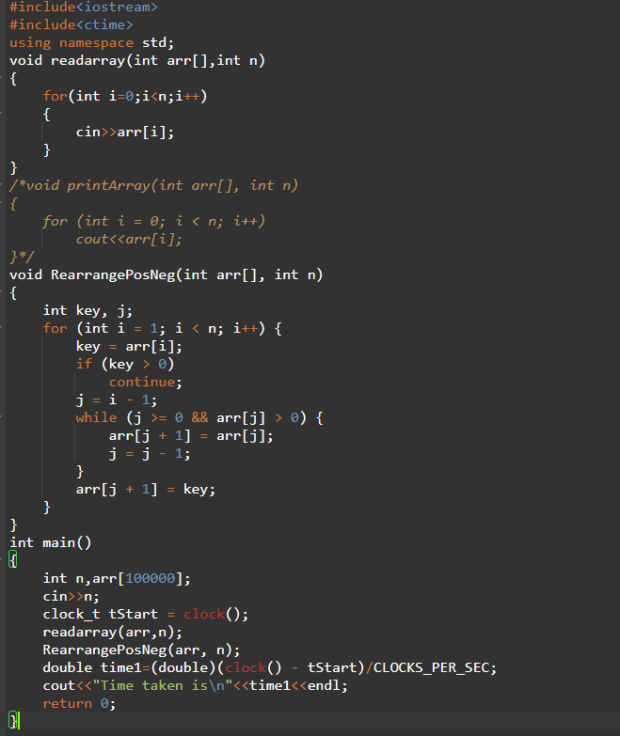

**Analysis:**

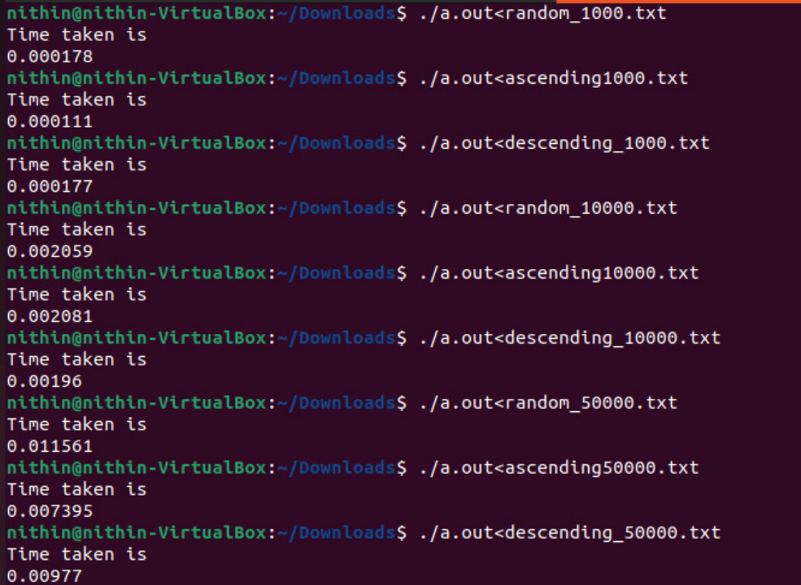

**Graph:**

